Tectonic Plates
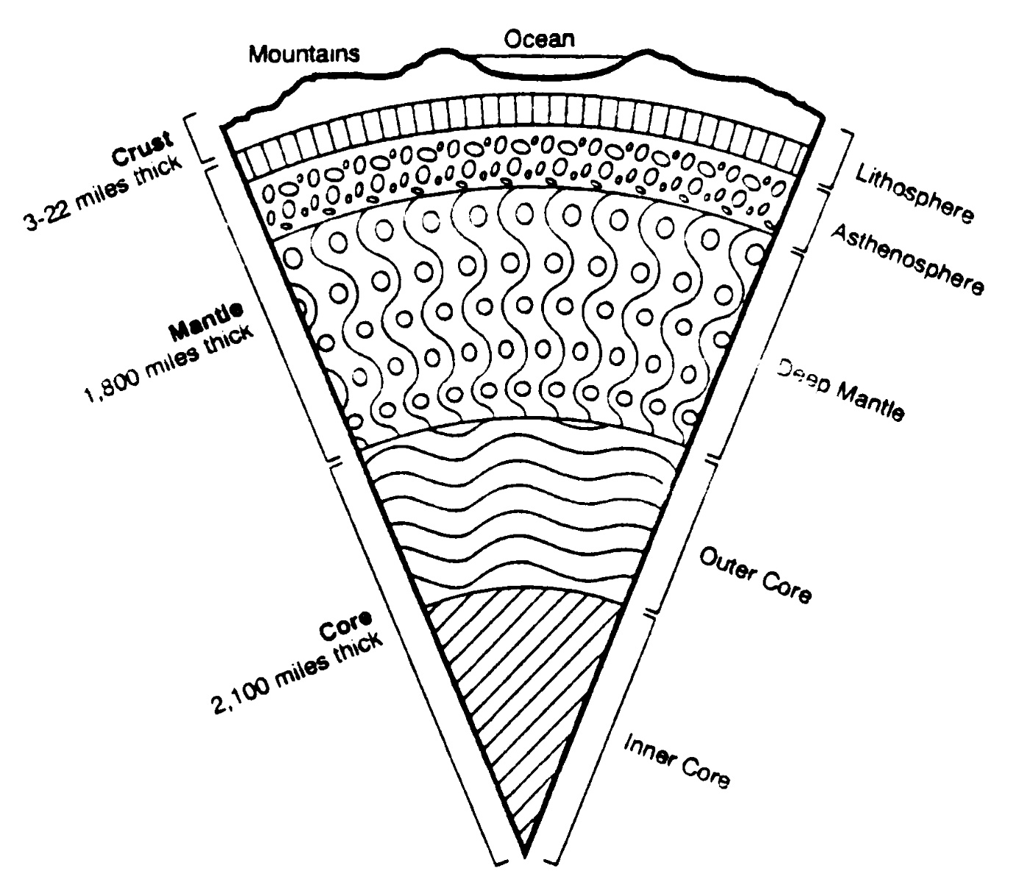
What are they?
Plate tectonics refers to the ______________________________. As plate tectonics operate over time, the __________, ___________ and __________ of the world’s continents and oceans slowly change. This movement has a major impact on the evolution of _________________ on the Earth’s land surfaces and ocean floors.
Why are they important?
Landforms are ______________ and _____________ at the edges of the plates. There is a strong relationship between tectonic plates and the occurrence of _______________ and ________________.

Type of Plate Movement
Motion of plates
Effects
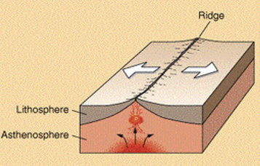 |  | 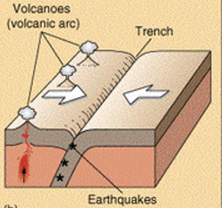 | 